Processes

# Processes

 Process Concept  Process Scheduling

 Operations on Processes

# Objectives

 To introduce the notion of a process -- a program in execution, which forms the basis of all computation

 To describe the various features of processes, including scheduling, creation and termination, and communication

 To explore interprocess communication using shared memory and message passing

 To describe communication in client-server systems

# Process Concept

 An operating system executes a variety of programs:  Batch system – **jobs**

 Time-shared systems – **user programs** or **tasks**

 Textbook uses the terms ***job*** and ***process*** almost interchangeably

 **Process** – a program in execution; process execution must progress in sequential fashion

 Multiple parts

 The program code, also called **text section**

 Current activity including **program counter**, processor registers

 **Stack** containing temporary data

 Function parameters, return addresses, local variables

 **Data section** containing global variables

 **Heap** containing memory dynamically allocated during run time

# Process Concept (Cont.)

 Program is ***passive*** entity stored on disk (**executable file**), process is ***active***

 Program becomes process when executable file loaded into memory

 Execution of program started via GUI mouse clicks, command line entry of its name, etc

 One program can be several processes

 Consider multiple users executing the same program

# Process in Memory

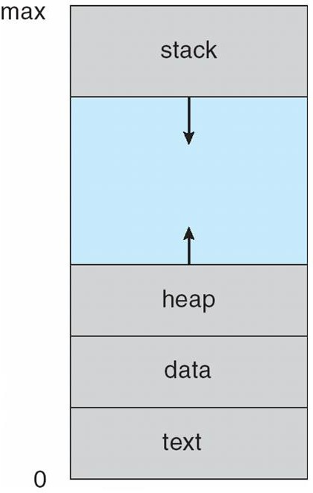

**Process State**

 As a process executes, it changes **state ** **new**: The process is being created

 **running**: Instructions are being executed

 **waiting**: The process is waiting for some event to occur

 **ready**: The process is waiting to be assigned to a processor

 **terminated**: The process has finished execution

# Diagram of Process State

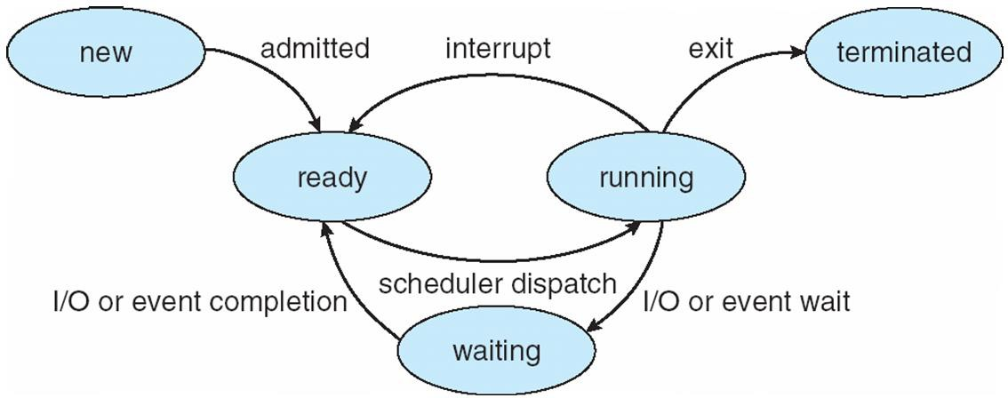

**Process Control Block (PCB)**

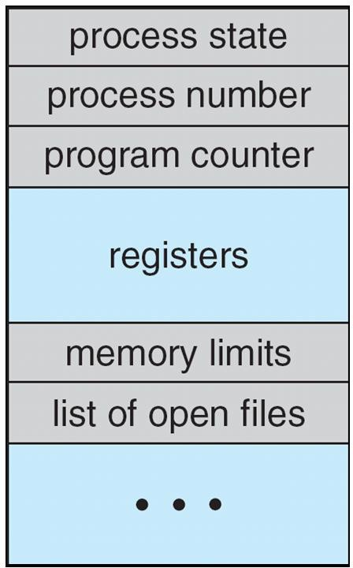Information associated with each process (also called **task control block**)

 Process state – running, waiting, etc

 Program counter – location of instruction to next execute

 CPU registers – contents of all process- centric registers

 CPU scheduling information- priorities, scheduling queue pointers

 Memory-management information – memory allocated to the process

 Accounting information – CPU used, clock time elapsed since start, time limits

 I/O status information – I/O devices allocated to process, list of open files

# CPU Switch From Process to Process

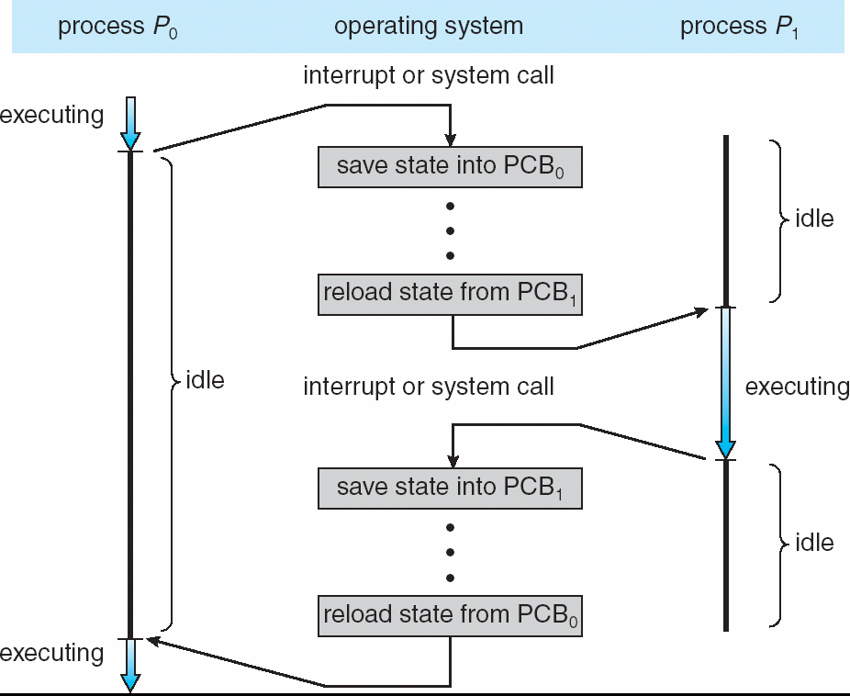

**Threads**

 So far, process has a single thread of execution

 Consider having multiple program counters per process  Multiple locations can execute at once

 Multiple threads of control -> **threads**

 Must then have storage for thread details, multiple program counters in PCB

 See next week

# Process Representation in Linux

Represented by the C structure task_struct

pid t_pid; /* process identifier */ long state; /* state of the process */

unsigned int time_slice /* scheduling information */ struct task_struct *parent; /* this process’s parent */ struct list_head children; /* this process’s children */ struct files_struct *files; /* list of open files */

struct mm_struct *mm; /* address space of this process */

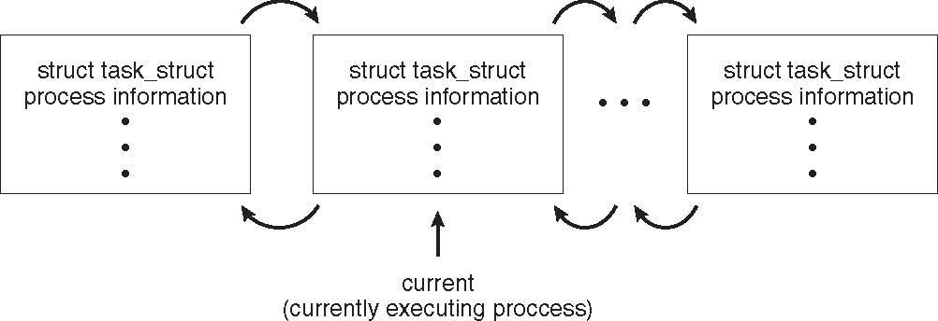

# Process Scheduling

 Maximize CPU use, quickly switch processes onto CPU for time sharing

 **Process scheduler** selects among available processes for next execution on CPU

 Maintains **scheduling queues** of processes

 **Job queue** – set of all processes in the system

 **Ready queue** – set of all processes residing in main memory, ready and waiting to execute

 **Device queues** – set of processes waiting for an I/O device  Processes migrate among the various queues

**Ready Queue And Various I/O Device Queues**

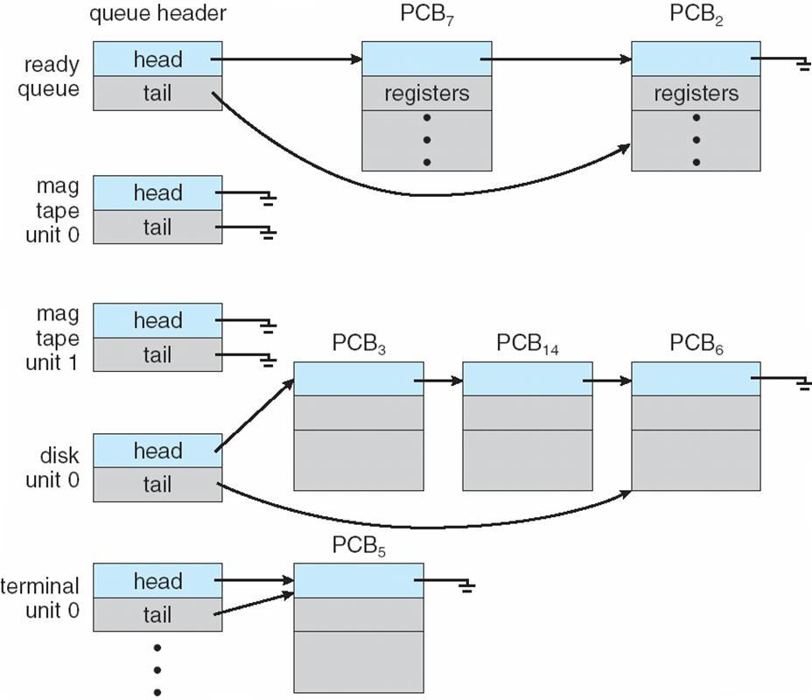

## Representation of Process Scheduling

 **Queueing diagram** represents queues, resources, flows

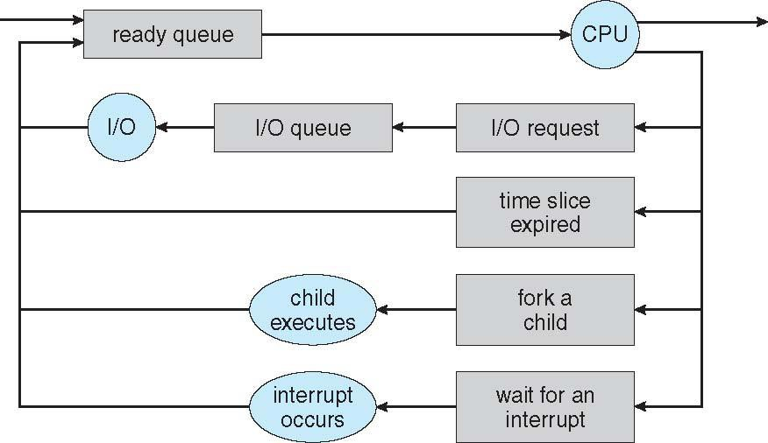

# Schedulers

 **Short-term scheduler** (or **CPU scheduler**) – selects which process should be executed next and allocates CPU

 Sometimes the only scheduler in a system

 Short-term scheduler is invoked frequently (milliseconds)  (must be fast)

 **Long-term scheduler** (or **job scheduler**) – selects which processes should be brought into the ready queue

 Long-term scheduler is invoked infrequently (seconds, minutes) 

(may be slow)

 The long-term scheduler controls the **degree of multiprogramming**

 Processes can be described as either:

 **I/O-bound process** – spends more time doing I/O than computations, many short CPU bursts

 **CPU-bound process** – spends more time doing computations; few very long CPU bursts

******Long-term scheduler strives for good ***process mix***

# Addition of Medium Term Scheduling

 **Medium-term scheduler** can be added if degree of multiple programming needs to decrease

 Remove process from memory, store on disk, bring back in from disk to continue execution: **swapping**

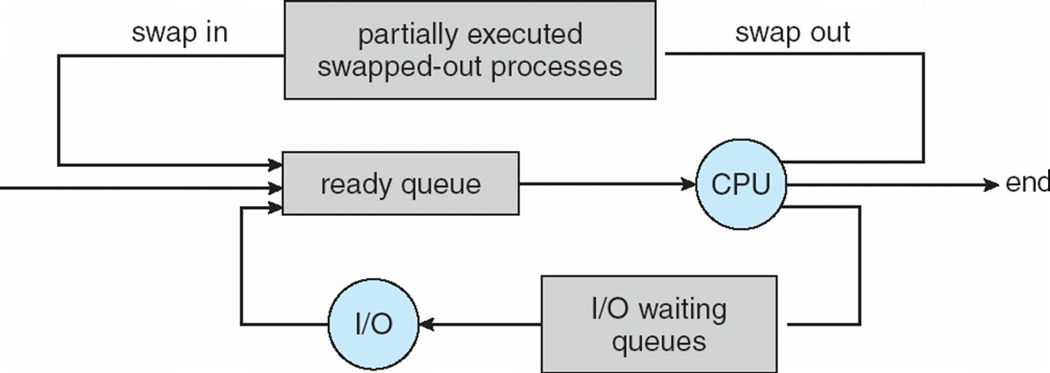

# Multitasking in Mobile Systems

 Some mobile systems (e.g., early version of iOS) allow only one process to run, others suspended

 Due to screen real estate, user interface limits iOS provides for a  Single **foreground** process- controlled via user interface

 Multiple **background** processes– in memory, running, but not on the display, and with limits

 Limits include single, short task, receiving notification of events, specific long-running tasks like audio playback

 Android runs foreground and background, with fewer limits  Background process uses a **service** to perform tasks

 Service can keep running even if background process is suspended

 Service has no user interface, small memory use

# Context Switch

 When CPU switches to another process, the system must **save the state** of the old process and load the **saved state** for the new process via a **context switch**

 **Context** of a process represented in the PCB

 Context-switch time is overhead; the system does no useful work while switching

 The more complex the OS and the PCB ➔ the longer the context switch

 Time dependent on hardware support

 Some hardware provides multiple sets of registers per CPU

➔ multiple contexts loaded at once

# Operations on Processes

 System must provide mechanisms for:  process creation,

 process termination,

 and so on as detailed next

# Process Creation

 **Parent** process create **children** processes, which, in turn create other processes, forming a **tree** of processes

 Generally, process identified and managed via a **process identifier** (**pid**)

 Resource sharing options

 Parent and children share all resources

 Children share subset of parent’s resources  Parent and child share no resources

 Execution options

 Parent and children execute concurrently  Parent waits until children terminate

# A Tree of Processes in Linux

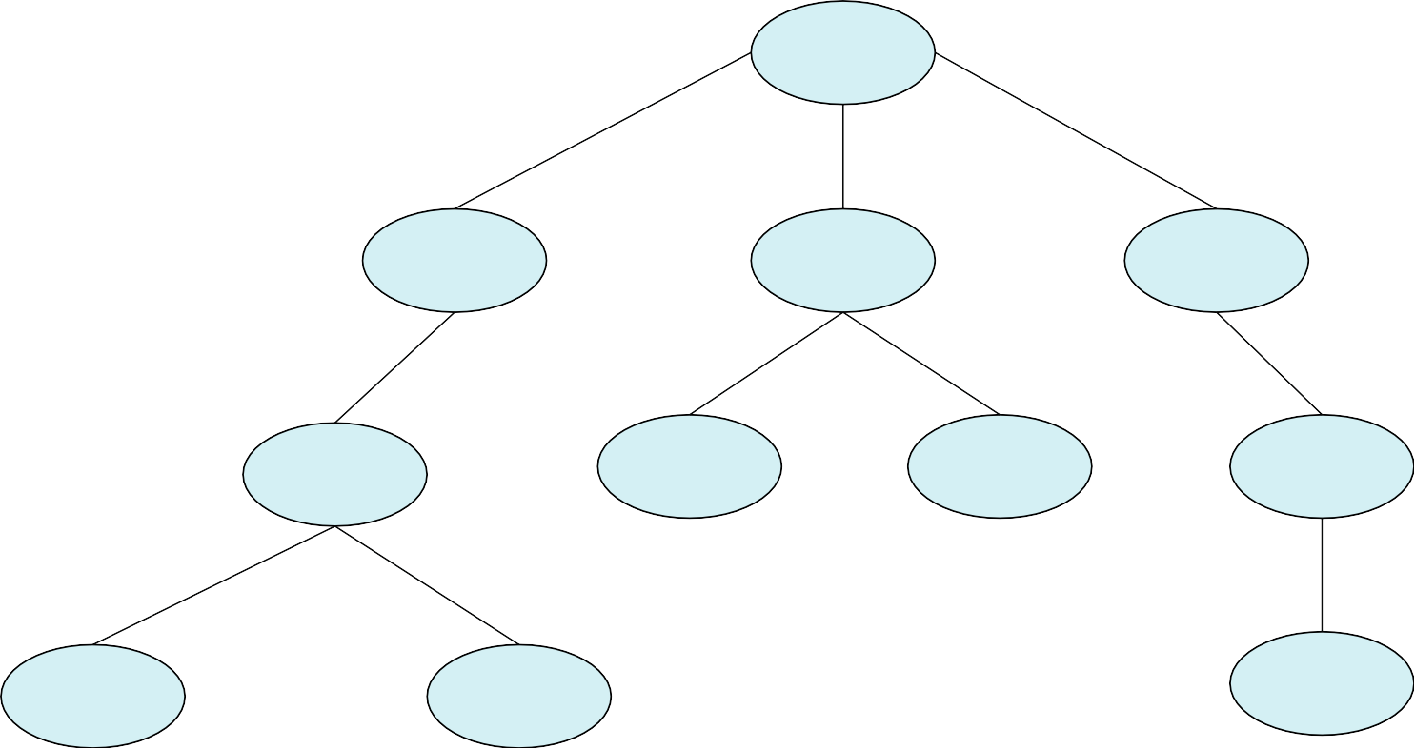

**init pid = 1**

**login pid = 8415**

**kthreadd pid = 2**

**sshd pid = 3028**

**bash pid = 8416**

**khelper pid = 6**

**pdflush pid = 200**

**sshd pid = 3610**

**ps pid = 9298**

**emacs pid = 9204**

**tcsch pid = 4005**

**Process Creation (Cont.)**

 Address space

 Child duplicate of parent

 Child has a program loaded into it  UNIX examples

 **fork()** system call creates new process

 **exec()** system call used after a **fork()** to replace the process’ memory space with a new program

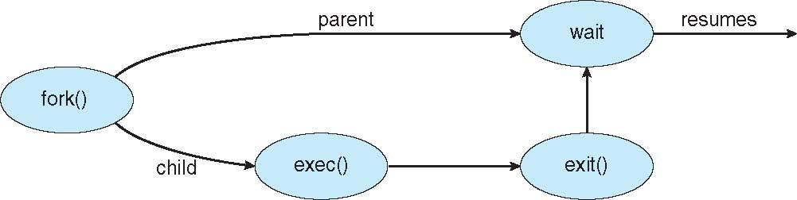

# C Program Forking Separate Process

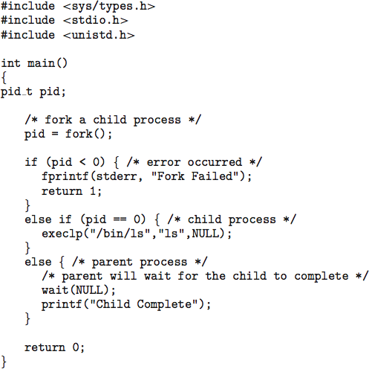

**Creating a Separate Process via Windows API**

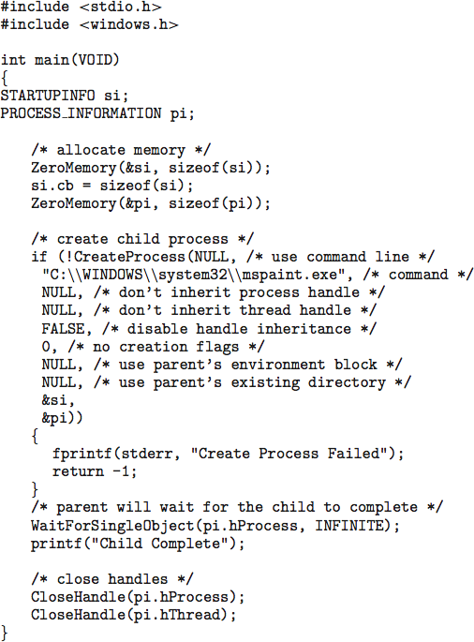

# Process Termination

 Process executes last statement and then asks the operating system to delete it using the **exit()** system call.

 Returns status data from child to parent (via **wait()**)  Process’ resources are deallocated by operating system

 Parent may terminate the execution of children processes using the **abort()** system call. Some reasons for doing so:

 Child has exceeded allocated resources

 Task assigned to child is no longer required

 The parent is exiting and the operating systems does not allow a child to continue if its parent terminates

# Process Termination

 Some operating systems do not allow child to exists if its parent has terminated. If a process terminates, then all its children must also be terminated.

 **cascading termination.** All children, grandchildren, etc. are terminated.

 The termination is initiated by the operating system.

 The parent process may wait for termination of a child process by using the **wait()**system call**.** The call returns status information and the pid of the terminated process

**pid = wait(&status);**

 If no parent waiting (did not invoke **wait()**) process is a **zombie**

 If parent terminated without invoking **wait** , process is an **orphan**

## Multiprocess Architecture – Chrome Browser

 Many web browsers ran as single process (some still do)

 If one web site causes trouble, entire browser can hang or crash  Google Chrome Browser is multiprocess with 3 different types of

processes:

 **Browser** process manages user interface, disk and network I/O

 **Renderer** process renders web pages, deals with HTML, Javascript. A new renderer created for each website opened

 Runs in **sandbox** restricting disk and network I/O, minimizing effect of security exploits

 **Plug-in** process for each type of plug-in

